OS Assignment-10

Jeetu Mehra
U24AI032

Question 1 : To Write a C program to simulate producer-consumer problem using semaphores.
Code:
#include <stdio.h>
#include <stdlib.h>
#include <pthread.h>
#include <semaphore.h>

#define BUFFER_SIZE 5

int buffer[BUFFER_SIZE];
int in = 0, out = 0;

sem_t empty, full;
pthread_mutex_t mutex;

void *producer(void *arg) {
int item;
for(int i = 0; i < 10; i++) {
item = rand() % 100;

sem_wait(&empty);
pthread_mutex_lock(&mutex);

buffer[in] = item;
printf("Produced: %d\n", item);
in = (in + 1) % BUFFER_SIZE;

pthread_mutex_unlock(&mutex);
sem_post(&full);
}
}

void *consumer(void *arg) {
int item;
for(int i = 0; i < 10; i++) {

sem_wait(&full);
pthread_mutex_lock(&mutex);

item = buffer[out];
printf("Consumed: %d\n", item);
out = (out + 1) % BUFFER_SIZE;

pthread_mutex_unlock(&mutex);
sem_post(&empty);
}
}

int main() {
pthread_t p, c;

sem_init(&empty, 0, BUFFER_SIZE);
sem_init(&full, 0, 0);
pthread_mutex_init(&mutex, NULL);

pthread_create(&p, NULL, producer, NULL);
pthread_create(&c, NULL, consumer, NULL);

pthread_join(p, NULL);
pthread_join(c, NULL);

return 0;
}
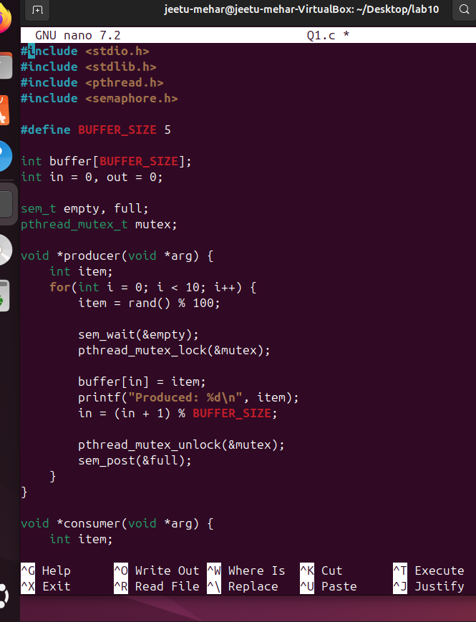

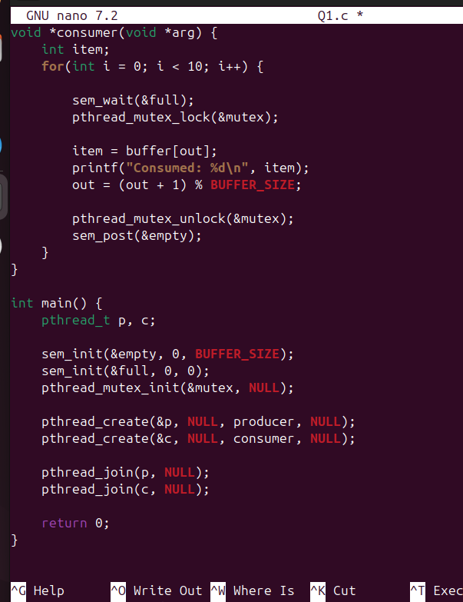
Output:
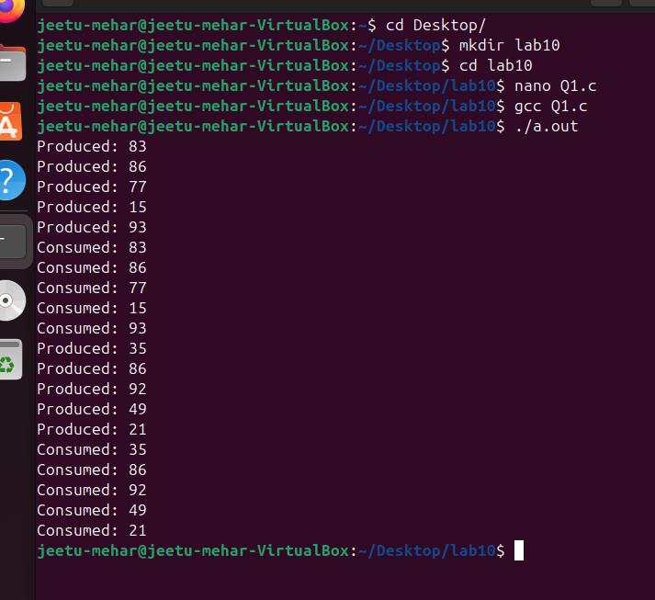

Question 2 : Write a C program to simulate the concept of Dining-Philosophers problem.
Code:
#include <stdio.h>
#include <pthread.h>
#include <semaphore.h>
#include <unistd.h>

#define N 5

sem_t chopstick[N];

void *philosopher(void *num) {
int id = *(int *)num;

while(1) {
printf("Philosopher %d is thinking\n", id);
sleep(1);

sem_wait(&chopstick[id]);
sem_wait(&chopstick[(id + 1) % N]);

printf("Philosopher %d is eating\n", id);
sleep(1);

sem_post(&chopstick[id]);
sem_post(&chopstick[(id + 1) % N]);
}
}

int main() {
pthread_t ph[N];
int id[N];

for(int i = 0; i < N; i++) {
sem_init(&chopstick[i], 0, 1);
}

for(int i = 0; i < N; i++) {
id[i] = i;
pthread_create(&ph[i], NULL, philosopher, &id[i]);
}

for(int i = 0; i < N; i++) {
pthread_join(ph[i], NULL);
}

return 0;
}

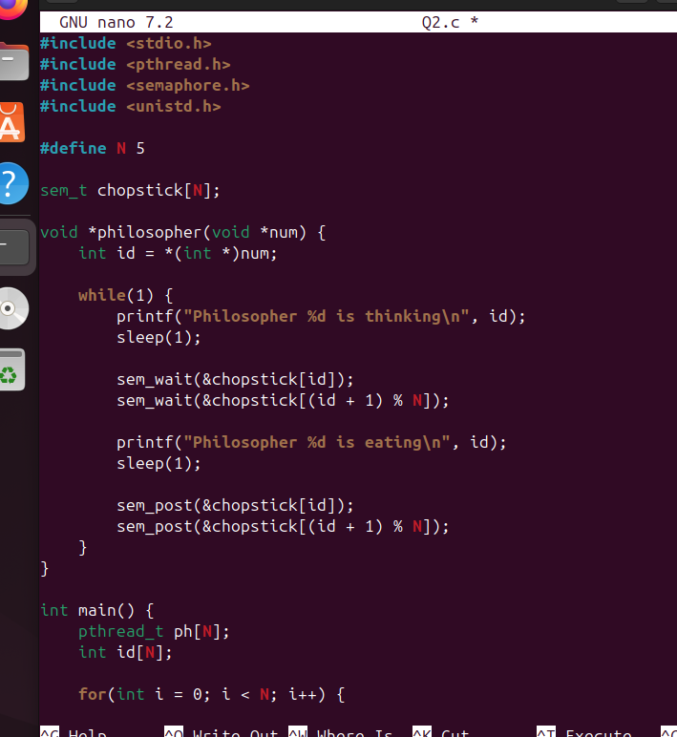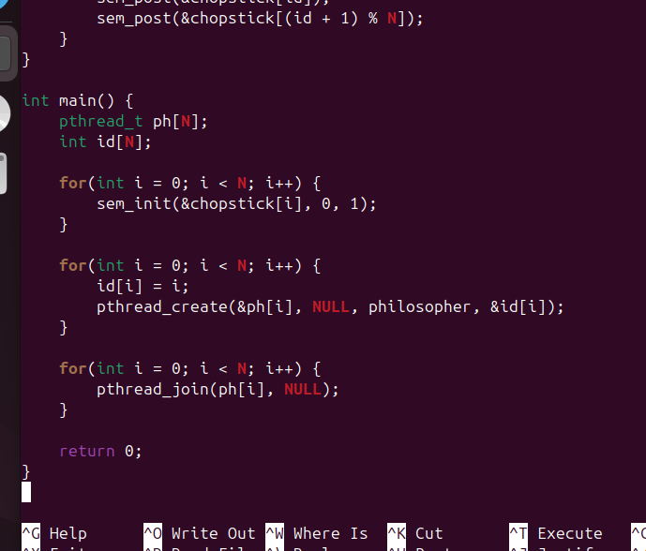

Output:

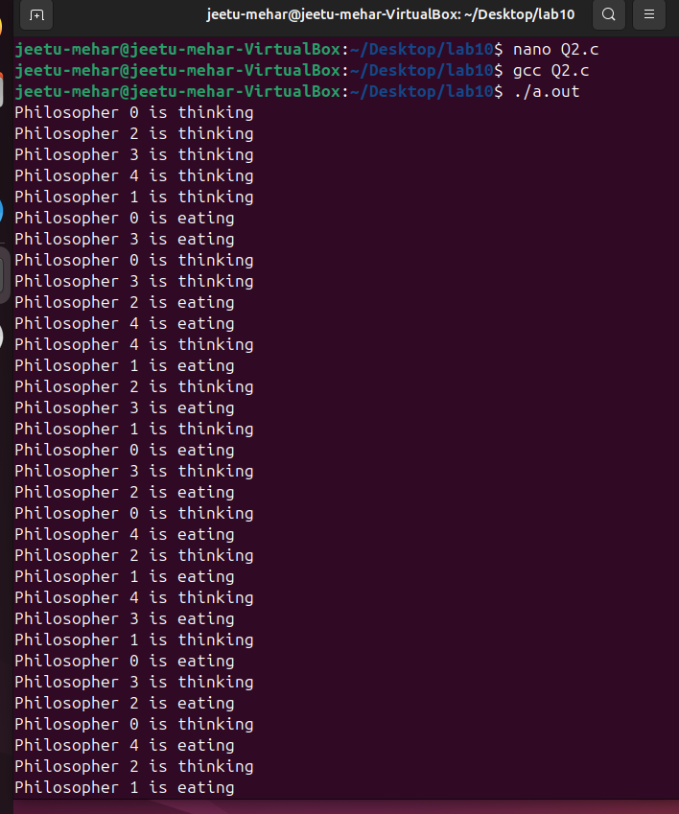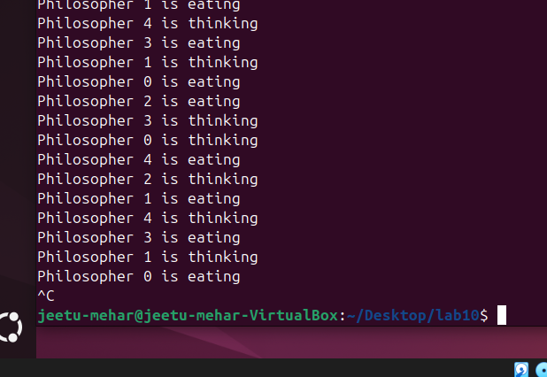

Question 3 : Write a C program to simulate the concept of Readers-Writers problem.
Code:
#include <stdio.h>
#include <pthread.h>
#include <semaphore.h>
#include <unistd.h>

sem_t wrt;
pthread_mutex_t mutex;

int read_count = 0;

void *reader(void *arg) {
int id = *(int *)arg;

pthread_mutex_lock(&mutex);
read_count++;
if(read_count == 1)
sem_wait(&wrt);
pthread_mutex_unlock(&mutex);

printf("Reader %d is reading\n", id);
sleep(1);

pthread_mutex_lock(&mutex);
read_count--;
if(read_count == 0)
sem_post(&wrt);
pthread_mutex_unlock(&mutex);
}

void *writer(void *arg) {
int id = *(int *)arg;

sem_wait(&wrt);

printf("Writer %d is writing\n", id);
sleep(1);

sem_post(&wrt);
}

int main() {
pthread_t r[5], w[2];
int id[5];

sem_init(&wrt, 0, 1);
pthread_mutex_init(&mutex, NULL);

for(int i = 0; i < 5; i++) {
id[i] = i;
pthread_create(&r[i], NULL, reader, &id[i]);
}

for(int i = 0; i < 2; i++) {
id[i] = i;
pthread_create(&w[i], NULL, writer, &id[i]);
}

for(int i = 0; i < 5; i++)
pthread_join(r[i], NULL);

for(int i = 0; i < 2; i++)
pthread_join(w[i], NULL);

return 0;
}

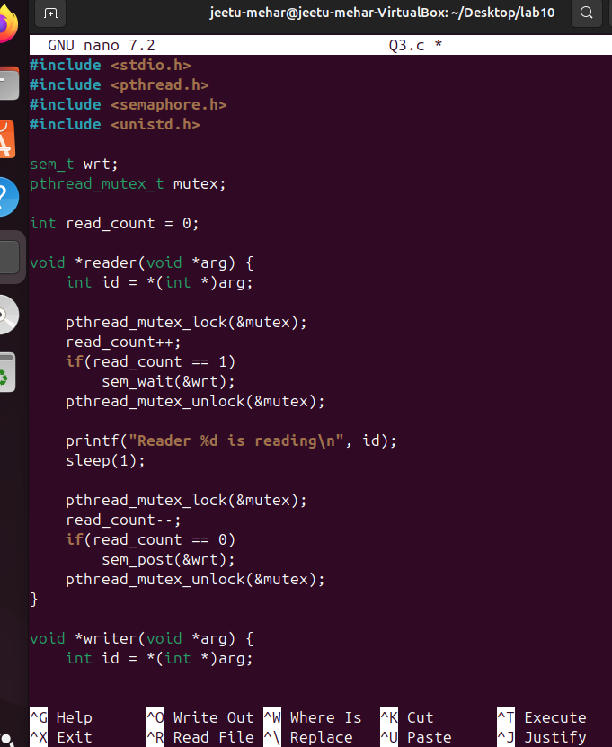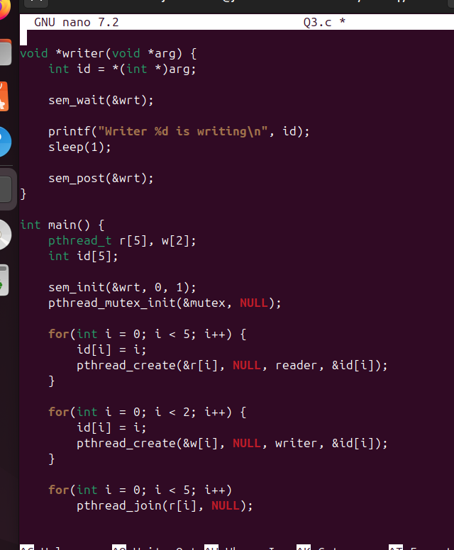

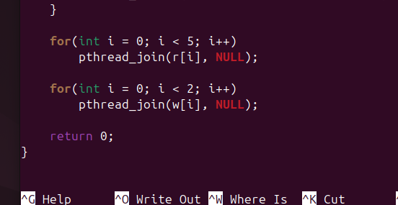

Output:

